Critique, Correct, & Clarify Note-catcher

What to Expect

This video will…
- Introduce the Math Language Routine (MLR) Critique, Correct, & Clarify
- Model Critique, Correct, & Clarify
- Offer a guide to the routine
- Connect to resources for future inquiry and practice
This video is most effective when…
- Paused at critical reflection points
- Paired with the guide and note-catcher
- Experienced with a coach or colleague
- Viewed multiple times as you grow

Apply
Use the space below to model the routine as you watch the video.

Interpreting the Slope and Vertical Intercept of a Linear Model
The scatter plot shows the sale price of several food items, $y$, and the cost of the ingredients used to produce those items, $x$, as well as a line that models the data. The line is also represented by the equation $y = 3.48x + 0.76$.
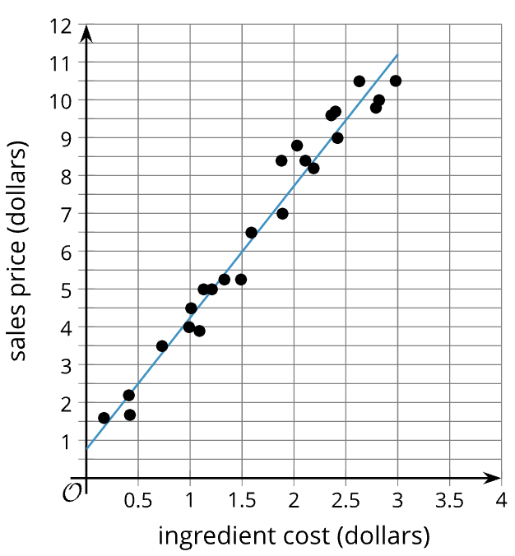
- What is the predicted sale price of an item that has ingredients that cost $1.50? Be prepared to show your reasoning.

- What is the predicted ingredient cost of an item that has a sale price of $7? Be prepared to show your reasoning.

- What is the slope of the linear model? What does that mean in this situation?

- What does the slope value mean in this situation?

- What is the y-intercept of the linear model?

- What does the value of the y-intercept mean in this situation?

- Does the value of the y-intercept make sense in this situation?

Check Your Understanding
Summarize Critique, Correct, & Clarify as a series of four steps.

During the routine, what are the teacher and students thinking about?
Teacher

Student

Understanding Critique, Correct, & Clarify

Maximizing Meta-Awareness
Facilitate opportunities for students to think about their own thinking and language use.
Optimizing Output
Facilitate opportunities for students to describe their mathematical thinking orally, visually, and in writing.

Check Your Understanding
Is the goal of Critique, Correct, & Clarify to solve a mathematical task?

Critique, Correct, & Clarify Plan
First, identify an Algebra 1 task for the routine:

Second, plan to apply the routine:

Steps to Apply Routine:
- Present
- Prompt
- Share
- Refine
Third, optimize the routine:

Fourth, extend the routine:

